Video Stabilization Application

**Group 3**

Ahmad Alaa Abd El-Wahab (1)

Ahmad Abd El-Latif Mhana (1)

Ahmad Magdy Muhammad (1)

Algorithms

SIFT Features:

* Feature Detection & Extraction

Matching:

* KD-Tree

Warping:

Gets the Transformation between the current Frame and Matching frame, Using Ransac Form to Create Homography Matrix that can describe the Transformation in SIFT Features … the benefit is that it also deals with zoom, pan, rotate, scaling … etc.

Stabilization in Words:

The Idea of the Application is to detect the motion in each frame, and create a warped frame for each, then using Mosaicing to fill the undefined edges in each warped frame.

SIFT Features: First of all we should detect features in the frame that is invariant to scale – rotate- pan – or whatever affects the video, these features could be “SIFT or SURF” or any other detection algorithm,

Matching: After that we should use Matching between two frames using nearest neighbor algorithm (KD-Tree).

I renew the match frame if I couldn’t create a Homography matrix due to “not enough matches”, so if I couldn’t get 4 points to create result that is near the match frame, I get a new match frame from the video.

Warping: Then a Ransac form is used to create a least-squares planar Homography (3X3) Matrix to describe the transformation between these two frames, using the scale invariant features and nearest neighbor algorithm, Ransac form is able to create a transformation matrix that describes the scale, pan, zoom and rotation affected the frame.

Using a perspective transform to create a warped frame, to generate the common part between the two frames, in its position in the matching frame, to look like it didn’t move.

But this will result in an undefined regions appeared near the edge.

So we should use Mosaicing to fill these parts from the previous frames (future work).

Inputs:

If I have 2 input images





So the SIFT Features should look like

OpenCV2.3 SIFT Feature detection and Extraction

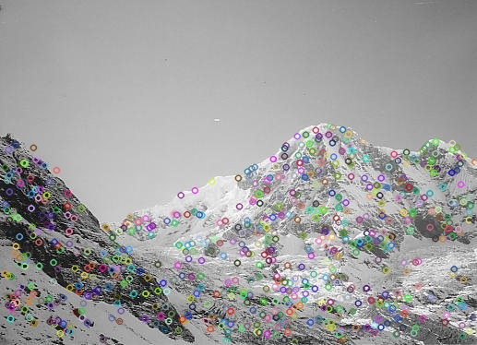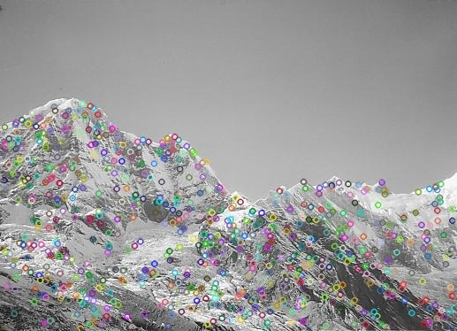

Rob Hoss Implementation (Open Source Code)

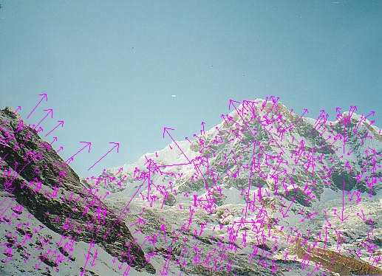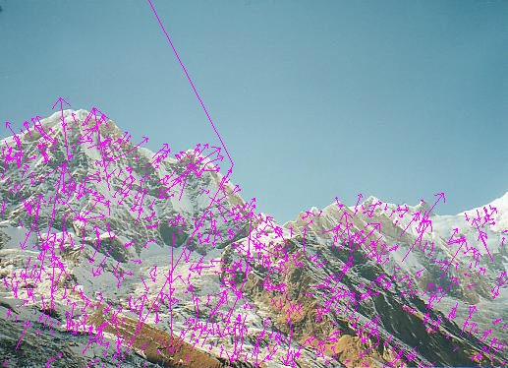

SIFT Feature Matching should look like

 

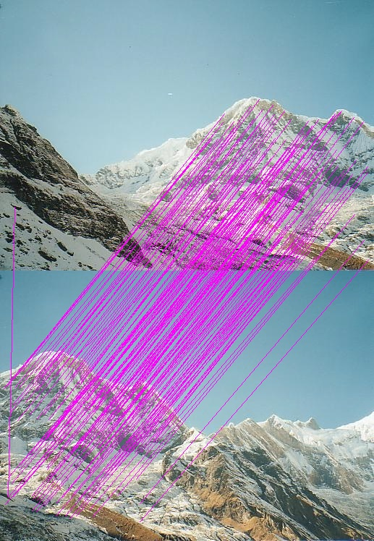

Warped Image

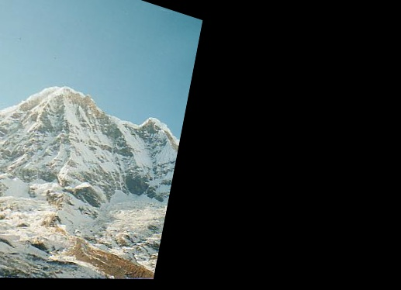

References

1. Video Stabilization Using Scale-Invariant Features
2. Full-frame Video Stabilization
3. Probabilistic video stabilization using kalman filtering and mosaicking
4. Recognising Panoramas
5. Distinctive Image Features from Scale-Invariant key points.
6. Source Code: methods embodied in this software:

* "Method and apparatus for identifying scale invariant features in an image and use of same for locating an object in an image," David G. Lowe

Rob Hess [hess@eecs.oregonstate.edu](mailto:hess@eecs.oregonstate.edu)